Learners’ Survey
Academic Year 2025-2026
Elementary Girls Campus
Dated: October , 2025
GRADE 6 – Venus
Total Reponses: 20

Q#1: Which teachers encourage you the most to ask questions about the topics being studied and are happy to answer them? *You may select as many options as you like.
Name | Responses | Percentage
Ms. Mehrunisa Kazmi-English | 13 | 27%
Ms. Maria Raza- Urdu | 9 | 18%
Ms. Ayesha Usman - Computing | 9 | 18%
Ms. Shehla Abbasi- Islamiat | 8 | 16%
Ms. Amina Masood-History | 4 | 8%
Ms. Asma Inam- Geography | 3 | 6%
Ms. Asia Nadeem- Science | 2 | 4%
Ms. Nousheen Khurram- Maths | 1 | 2%
None of the above | 0 | 0%

Q#2: Which teachers report late for the class? * (You may select as many options as you like.)*
Name | Responses | Percentage
None of the above | 14 | 70%
Ms. Mehrunisa Kazmi-English | 2 | 10%
Ms. Nousheen Khurram- Maths | 2 | 10%
Ms. Asia Nadeem- Science | 1 | 5%
Ms. Amina Masood-History | 1 | 5%
Ms. Maria Raza- Urdu | 0 | 0%
Ms. Shehla Abbasi- Islamiat | 0 | 0%
Ms. Asma Inam- Geography | 0 | 0%
Ms. Ayesha Usman - Computing | 0 | 0%

Q#3: Which teachers conclude their classes before the allotted time? * (You may select as many options as you like.)
Name | Responses | Percentage
None of the above | 11 | 52%
Ms. Nousheen Khurram- Maths | 7 | 33%
Ms. Maria Raza- Urdu | 2 | 10%
Ms. Mehrunisa Kazmi-English | 1 | 5%
Ms. Asia Nadeem- Science | 0 | 0%
Ms. Shehla Abbasi- Islamiat | 0 | 0%
Ms. Asma Inam- Geography | 0 | 0%
Ms. Amina Masood-History | 0 | 0%
Ms. Ayesha Usman - Computing | 0 | 0%

Q#4: Which teachers indulge in irrelevant discussions. * (You may select as many options as you like.)
Name | Responses | Percentage
None of the above | 9 | 39%
Ms. Nousheen Khurram- Maths | 7 | 30%
Ms. Mehrunisa Kazmi-English | 3 | 13%
Ms. Shehla Abbasi- Islamiat | 2 | 9%
Ms. Maria Raza- Urdu | 1 | 4%
Ms. Ayesha Usman - Computing | 1 | 4%
Ms. Asia Nadeem- Science | 0 | 0%
Ms. Asma Inam- Geography | 0 | 0%
Ms. Amina Masood-History | 0 | 0%

Q#5: Which teachers use cell phones in their classes? * (You may select as many options as you like.)
Name | Responses | Percentage
None of the above | 12 | 55%
Ms. Nousheen Khurram- Maths | 8 | 36%
Ms. Mehrunisa Kazmi-English | 1 | 5%
Ms. Maria Raza- Urdu | 1 | 5%
Ms. Asia Nadeem- Science | 0 | 0%
Ms. Shehla Abbasi- Islamiat | 0 | 0%
Ms. Asma Inam- Geography | 0 | 0%
Ms. Amina Masood-History | 0 | 0%
Ms. Ayesha Usman - Computing | 0 | 0%

Q#6. Which teacher asks you to take paid tuition from him/her in the evening to get an A* or a good grade?
Name | Responses | Percentage
None of the above | 19 | 86%
Ms. Mehrunisa Kazmi-English | 1 | 5%
Ms. Nousheen Khurram- Maths | 1 | 5%
Ms. Maria Raza- Urdu | 1 | 5%
Ms. Asia Nadeem- Science | 0 | 0%
Ms. Shehla Abbasi- Islamiat | 0 | 0%
Ms. Asma Inam- Geography | 0 | 0%
Ms. Amina Masood-History | 0 | 0%
Ms. Ayesha Usman - Computing | 0 | 0%

Q#7. Which subject do you find most challenging?
Name | Responses | Percentage
Ms. Nousheen Khurram- Maths | 12 | 44%
Ms. Asma Inam- Geography | 8 | 30%
Ms. Ayesha Usman - Computing | 2 | 7%
None of the above | 2 | 7%
Ms. Mehrunisa Kazmi-English | 1 | 4%
Ms. Asia Nadeem- Science | 1 | 4%
Ms. Maria Raza- Urdu | 1 | 4%
Ms. Shehla Abbasi- Islamiat | 0 | 0%
Ms. Amina Masood-History | 0 | 0%

Q#8. How would you rate the teacher’s overall performance?
Name | Ranking
Ms. Mehrunisa Kazmi-English | 1
Ms. Maria Raza- Urdu | 2
Ms. Ayesha Usman - Computing | 3
Ms. Shehla Abbasi- Islamiat | 4
Ms. Asia Nadeem- Science | 5
Ms. Amina Masood-History | 6
Ms. Asma Inam- Geography | 7
Ms. Nousheen Khurram- Maths | 8

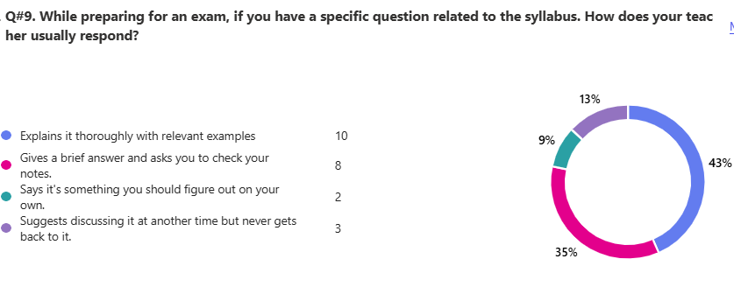
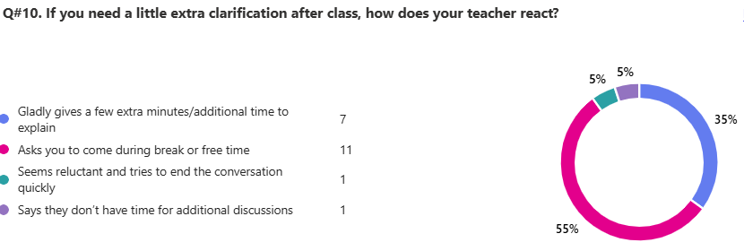

Any feedback that you would like to share with Board of Directors.

ID | Responses
1 | I think all the teachers are the nice and loving to all students
2 | please fix the bathrooms :)
3 | Although, I love all of the teachers, I would appreciate Maam Nousheen Khurram to be a bit nicer as i continuesly get yelled at by her without any reason. Favouritism is also being involved which makes a lot of children feel sad and excluded in conversations. Thank you for reading my feedback about her!
4 | I WOULD LIKE TO SHARE THAT THERE ARE SOME TEACHER SHOULD NOT DO ANY FAVOURITIZIM SO NO ONE CAN FEEL LONELY
5 | OVERALL ALL TEACHER ARE REALLY GOOD BUT SOME ARE KIND OF GOOD . KEEP IT UP TEACHERS
6 | ma'am nosheen she does favouritism if we ask a question she says why didn't you listen. she bangs on the board even though we are quiet if someone gets to be house charge or class representative she is like why did you become this and you aren't that capable of it and makes fun of this
7 | A little nice and also the teachings fine some of the teachers are very strict and get angry in small things especially maam Nousheen some of the students are mostly scared t ask the teacher because they get angry in little things
8 | Although the teaching isnt the worst, most teachers are very very strict. Some even teach poorly because of either their lack of answering questions, or because they're so strict you're too scared to ask any questions. I understand school is a place of learning, but I believe nor do they interact with students, nor do they let any students have any form of enjoyment
9 | they school keep an eye on the students if they are getting bullied or they are not ok and to make the school a little fun
10 | TEACHERS SHOLD LISTEN TO ALL THE STUDENTS .
11 | all the teachers are extremely kind and barely show any favouritism. if you have questions they answer it or ask you to come to them in break for longer answers or explanations.
GRADE 6 – Mercury
Total Reponses: 19

Q#1: Which teachers encourage you the most to ask questions about the topics being studied and are happy to answer them? *You may select as many options as you like.
Name | Responses | Percentage
Ms. Ayesha Usman - Computing | 12 | 19%
Ms. Maria Raza- Urdu | 10 | 16%
Ms. Shehla Abbasi- Islamiat | 10 | 16%
Ms. Mehrunisa Kazmi-English | 7 | 11%
Ms. Asia Nadeem- Science | 7 | 11%
Ms. Romaisa Salman - Maths | 6 | 10%
Ms. Amina Masood-History | 6 | 10%
Ms. Asma Inam- Geography | 4 | 6%
None of the above | 0 | 0%

Q#2: Which teachers report late for the class? * (You may select as many options as you like.)*
Name | Responses | Percentage
None of the above | 14 | 67%
Ms. Mehrunisa Kazmi-English | 4 | 19%
Ms. Romaisa Salman - Maths | 1 | 5%
Ms. Asia Nadeem- Science | 1 | 5%
Ms. Amina Masood-History | 1 | 5%
Ms. Maria Raza- Urdu | 0 | 0%
Ms. Shehla Abbasi- Islamiat | 0 | 0%
Ms. Asma Inam- Geography | 0 | 0%
Ms. Ayesha Usman - Computing | 0 | 0%

Q#3: Which teachers conclude their classes before the allotted time? * (You may select as many options as you like.)
Name | Responses | Percentage
None of the above | 13 | 68%
Ms. Romaisa Salman - Maths | 2 | 11%
Ms. Maria Raza- Urdu | 2 | 11%
Ms. Shehla Abbasi- Islamiat | 1 | 5%
Ms. Asma Inam- Geography | 1 | 5%
Ms. Mehrunisa Kazmi-English | 0 | 0%
Ms. Asia Nadeem- Science | 0 | 0%
Ms. Amina Masood-History | 0 | 0%
Ms. Ayesha Usman - Computing | 0 | 0%

Q#4: Which teachers indulge in irrelevant discussions. * (You may select as many options as you like.)
Name | Responses | Percentage
None of the above | 8 | 33%
Ms. Asma Inam- Geography | 7 | 29%
Ms. Mehrunisa Kazmi-English | 5 | 21%
Ms. Romaisa Salman - Maths | 2 | 8%
Ms. Shehla Abbasi- Islamiat | 1 | 4%
Ms. Ayesha Usman - Computing | 1 | 4%
Ms. Asia Nadeem- Science | 0 | 0%
Ms. Maria Raza- Urdu | 0 | 0%
Ms. Amina Masood-History | 0 | 0%

Q#5: Which teachers use cell phones in their classes? * (You may select as many options as you like.)
Name | Responses | Percentage
None of the above | 12 | 53%
Ms. Mehrunisa Kazmi-English | 6 | 32%
Ms. Romaisa Salman - Maths | 3 | 16%
Ms. Asia Nadeem- Science | 0 | 0%
Ms. Maria Raza- Urdu | 0 | 0%
Ms. Shehla Abbasi- Islamiat | 0 | 0%
Ms. Asma Inam- Geography | 0 | 0%
Ms. Amina Masood-History | 0 | 0%
Ms. Ayesha Usman - Computing | 0 | 0%

Q#6. Which teacher asks you to take paid tuition from him/her in the evening to get an A* or a good grade?
Name | Responses | Percentage
None of the above | 18 | 90%
Ms. Romaisa Salman - Maths | 1 | 5%
Ms. Maria Raza- Urdu | 1 | 5%
Ms. Mehrunisa Kazmi-English | 0 | 0%
Ms. Asia Nadeem- Science | 0 | 0%
Ms. Shehla Abbasi- Islamiat | 0 | 0%
Ms. Asma Inam- Geography | 0 | 0%
Ms. Amina Masood-History | 0 | 0%
Ms. Ayesha Usman - Computing | 0 | 0%

Q#7. Which subject do you find most challenging?
Name | Responses | Percentage
Ms. Asma Inam- Geography | 11 | 30%
Ms. Romaisa Salman - Maths | 9 | 24%
Ms. Shehla Abbasi- Islamiat | 4 | 11%
Ms. Amina Masood-History | 3 | 8%
Ms. Ayesha Usman - Computing | 3 | 8%
None of the above | 3 | 8%
Ms. Mehrunisa Kazmi-English | 2 | 5%
Ms. Asia Nadeem- Science | 2 | 5%
Ms. Maria Raza- Urdu | 0 | 0%

Q#8. How would you rate the teacher’s overall performance?
Name | Ranking
Ms. Maria Raza- Urdu | 1
Ms. Mehrunisa Kazmi-English | 2
Ms. Shehla Abbasi- Islamiat | 3
Ms. Asia Nadeem- Science | 4
Ms. Ayesha Usman - Computing | 5
Ms. Romaisa Salman - Maths | 6
Ms. Amina Masood-History | 7
Ms. Asma Inam- Geography | 8

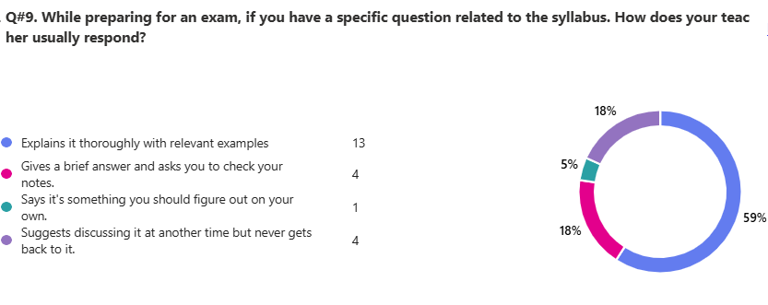

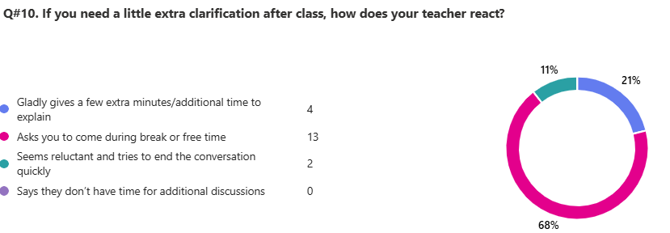

Any feedback that you would like to share with Board of Directors.

ID | Responses
1 | Nice teachers
2 | please do not tell the teachers
3 | All the teachers are very nice and listening, but in my opinion, our campus doesn't have many extra-curriular activities.
4 | all of the teachers are nice but some are little bias but their understanding concepts are crystal clear
5 | I don't understand some teachers subject for example the teach us something else in the class and in the paper, something else comes. Oh and please make the papers easier:)
6 | ALL THE TEACHERS ARE REALLY SWEET AND I LOVE THEM ALL MY TEACHERS ARE BEST TEACHERS EVER AND THEY WILL ALWAYS BE.
7 | My teachers are so nice and sweet to me I love all of them and thats all
8 | none
9 | the teachers are nice but ma'am romaisa the maths teacher is very rude with me and she scrames at me a lot but I get the best marks
10 | I personally do not like how certain teachers bring up politics or they overly stress out sometimes
11 | to be fair i do not like the classroom, but the maths teacher does not act properly. bathrooms suck and i can hardly understand most of what the teachers say. thank you
12 | I love all my teachers, sometimes the subjects are a bit difficult like geography and we have to memorise all of it, ms asthma geo just scolds a lot otherwise she makes us learn and have fun all the time! I have a concern that I don't really understand maths a lot, sometimes our math teacher asks a question and some of the smart kids in our class reply, only like 4-5 children which she says okay and doesn't think about the others that they understood or not? kids talk a lot but when my bff and I talk science an eng teacher changes and science our class teacher changed my bffs seat and only told us that she'll think if we can sit together on Fridays, she changed our seat for EVERY subject, I personally love all my teachers and they put all their efforts into our studies and I love all of them by heart and not just words :3, bye!
13 | when every I ask Urdu mam to tell me what mistake I did she never answer me , or something else that I didn't understand she never answered.
14 | I really like all the teachers but I can't understand maths and geography
15 | Please monitor the teachers more closely. Otherwise, It is all pretty good. Personally, I would like more events and clubs.

GRADE 6 – Mars
Total Reponses: 26

Q#1: Which teachers encourage you the most to ask questions about the topics being studied and are happy to answer them? *You may select as many options as you like.
Name | Responses | Percentage
Ms. Ayesha Usman - Computing | 21 | 22%
Ms. Maria Raza- Urdu | 19 | 20%
Ms. Shehla Abbasi- Islamiat | 12 | 13%
Ms. Saadia Ahmed-English | 10 | 11%
Ms. Sania Qaisar- Science | 10 | 11%
Ms. Sania Naveed- Maths | 9 | 10%
Ms. Amina Masood-History | 9 | 10%
Ms. Asma Inam- Geography | 4 | 4%
None of the above | 0 | 0%

Q#2: Which teachers report late for the class? * (You may select as many options as you like.)*
Name | Responses | Percentage
Ms. Sania Naveed- Maths | 14 | 44%
None of the above | 6 | 19%
Ms. Amina Masood-History | 5 | 16%
Ms. Asma Inam- Geography | 3 | 9%
Ms. Saadia Ahmed-English | 2 | 6%
Ms. Sania Qaisar- Science | 1 | 3%
Ms. Shehla Abbasi- Islamiat | 1 | 3%
Ms. Maria Raza- Urdu | 0 | 0%
Ms. Ayesha Usman - Computing | 0 | 0%

Q#3: Which teachers conclude their classes before the allotted time? * (You may select as many options as you like.)
Name | Responses | Percentage
None of the above | 13 | 34%
Ms. Sania Naveed- Maths | 5 | 13%
Ms. Sania Qaisar- Science | 5 | 13%
Ms. Saadia Ahmed-English | 4 | 11%
Ms. Asma Inam- Geography | 4 | 11%
Ms. Maria Raza- Urdu | 2 | 5%
Ms. Shehla Abbasi- Islamiat | 2 | 5%
Ms. Amina Masood-History | 2 | 5%
Ms. Ayesha Usman - Computing | 1 | 3%

Q#4: Which teachers indulge in irrelevant discussions. * (You may select as many options as you like.)
Name | Responses | Percentage
None of the above | 14 | 44%
Ms. Saadia Ahmed-English | 8 | 25%
Ms. Sania Naveed- Maths | 2 | 6%
Ms. Sania Qaisar- Science | 2 | 6%
Ms. Shehla Abbasi- Islamiat | 2 | 6%
Ms. Amina Masood-History | 2 | 6%
Ms. Maria Raza- Urdu | 1 | 3%
Ms. Asma Inam- Geography | 1 | 3%
Ms. Ayesha Usman - Computing | 0 | 0%

Q#5: Which teachers use cell phones in their classes? * (You may select as many options as you like.)
Name | Responses | Percentage
None of the above | 19 | 68%
Ms. Saadia Ahmed-English | 6 | 21%
Ms. Sania Naveed- Maths | 1 | 4%
Ms. Shehla Abbasi- Islamiat | 1 | 4%
Ms. Asma Inam- Geography | 1 | 4%
Ms. Sania Qaisar- Science | 0 | 0%
Ms. Maria Raza- Urdu | 0 | 0%
Ms. Amina Masood-History | 0 | 0%
Ms. Ayesha Usman - Computing | 0 | 0%

Q#6. Which teacher asks you to take paid tuition from him/her in the evening to get an A* or a good grade?
Name | Responses | Percentage
None of the above | 22 | 79%
Ms. Sania Naveed- Maths | 3 | 11%
Ms. Saadia Ahmed-English | 1 | 4%
Ms. Sania Qaisar- Science | 1 | 4%
Ms. Asma Inam- Geography | 1 | 4%
Ms. Maria Raza- Urdu | 0 | 0%
Ms. Shehla Abbasi- Islamiat | 0 | 0%
Ms. Amina Masood-History | 0 | 0%
Ms. Ayesha Usman - Computing | 0 | 0%

Q#7. Which subject do you find most challenging?
Name | Responses | Percentage
Ms. Asma Inam- Geography | 17 | 35%
Ms. Sania Naveed- Maths | 8 | 16%
Ms. Amina Masood-History | 7 | 14%
Ms. Saadia Ahmed-English | 6 | 12%
Ms. Ayesha Usman - Computing | 4 | 8%
Ms. Sania Qaisar- Science | 3 | 6%
Ms. Maria Raza- Urdu | 2 | 4%
Ms. Shehla Abbasi- Islamiat | 1 | 2%
None of the above | 1 | 2%

Q#8. How would you rate the teacher’s overall performance?
Name | Ranking
Ms. Ayesha Usman - Computing | 1
Ms. Maria Raza- Urdu | 2
Ms. Shehla Abbasi- Islamiat | 3
Ms. Saadia Ahmed-English | 4
Ms. Sania Naveed- Maths | 5
Ms. Sania Qaisar- Science | 6
Ms. Amina Masood-History | 7
Ms. Asma Inam- Geography | 8

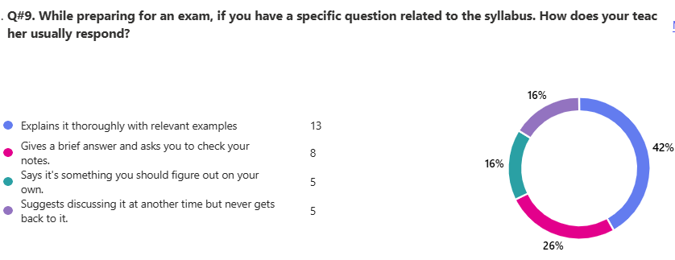

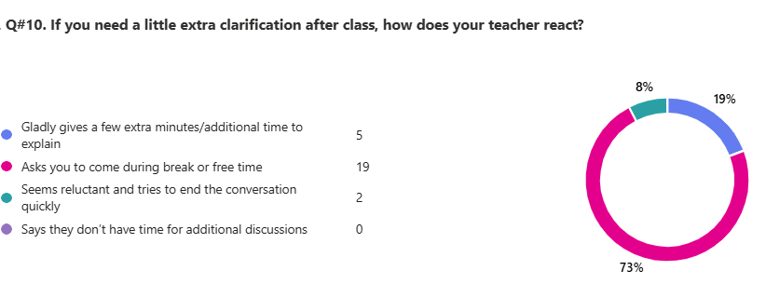

Any feedback that you would like to share with Board of Directors.

ID | Responses
1 | I want the Geography and History teacher to be changed .
2 | no
3 | I want the teachers to be nice and maths teacher also and the geo teacher is nice but not that much
4 | They all are good and friendly but sometime I feel little uncomfortable.
5 | the teachers should explain more briefly
6 | the geography mamas sooooo bad and I am hating my campus is really bad and small
7 | no
8 | I WOULD LIKE TO SAY TO FOLLOW THE HOME WORK SCEDULE
9 | ask teachers to make us do more past paper revision for our exams so we know how our exam is going to be
10 | our eng teacher said many things to us that we donot like
11 | The english maam is really strict and not nice
12 | NO
13 | after- school clubs
14 | ask the teachers to speak are English than Urdu
15 | I love my teachers. I would like the english teacher to make a little improvement but i love the maths teacher. she is the best teacher I've ever had
16 | MAAM Asma doesn't explain the topics she quickly starts the copy work . MAAM Ayesha Usman is the best teacher ever our class scored hGrade 6hest in computer . MAAM Sadia always praises herself and talks about how great she is . As the Class representative of 6 Mars I would like my teachers to encourage more revision thank you
17 | I would like if our teachers are kind with us. and some times don't Grade 6nore
18 | our math teacher is to strict

GRADE 6 – Earth
Total Reponses: 28

Q#1: Which teachers encourage you the most to ask questions about the topics being studied and are happy to answer them? *You may select as many options as you like.
Name | Responses | Percentage
Ms. Saadia Ahmed-English | 23 | 19%
Ms. Maria Raza- Urdu | 21 | 18%
Ms. Ayesha Usman - Computing | 18 | 15%
Ms. Amina Masood-History | 16 | 13%
Ms. Shehla Abbasi- Islamiat | 15 | 13%
Ms. Asma Inam- Geography | 7 | 6%
Ms. Nousheen Khurram- Maths | 6 | 5%
Ms. Sania Qaiser- Science | 5 | 10%
None of the above | 1 | 1%

Q#2: Which teachers report late for the class? * (You may select as many options as you like.)*
Name | Responses | Percentage
None of the above | 18 | 55%
Ms. Nousheen Khurram- Maths | 9 | 27%
Ms. Shehla Abbasi- Islamiat | 2 | 6%
Ms. Asma Inam- Geography | 2 | 6%
Ms. Saadia Ahmed-English | 1 | 3%
Ms. Maria Raza- Urdu | 1 | 3%
Ms. Sania Qaiser- Science | 0 | 0%
Ms. Amina Masood-History | 0 | 0%
Ms. Ayesha Usman - Computing | 0 | 0%

Q#3: Which teachers conclude their classes before the allotted time? * (You may select as many options as you like.)
Name | Responses | Percentage
None of the above | 15 | 35%
Ms. Maria Raza- Urdu | 7 | 16%
Ms. Saadia Ahmed-English | 5 | 12%
Ms. Asma Inam- Geography | 5 | 12%
Ms. Nousheen Khurram- Maths | 4 | 9%
Ms. Sania Qaiser- Science | 2 | 5%
Ms. Shehla Abbasi- Islamiat | 2 | 5%
Ms. Amina Masood-History | 2 | 5%
Ms. Ayesha Usman - Computing | 1 | 2%

Q#4: Which teachers indulge in irrelevant discussions. * (You may select as many options as you like.)
Name | Responses | Percentage
None of the above | 14 | 39%
Ms. Nousheen Khurram- Maths | 8 | 22%
Ms. Saadia Ahmed-English | 4 | 11%
Ms. Shehla Abbasi- Islamiat | 4 | 11%
Ms. Asma Inam- Geography | 2 | 6%
Ms. Ayesha Usman - Computing | 2 | 6%
Ms. Maria Raza- Urdu | 1 | 3%
Ms. Amina Masood-History | 1 | 3%
Ms. Sania Qaiser- Science | 0 | 0%

Q#5: Which teachers use cell phones in their classes? * (You may select as many options as you like.)
Name | Responses | Percentage
Ms. Nousheen Khurram- Maths | 14 | 48%
None of the above | 14 | 48%
Ms. Asma Inam- Geography | 1 | 3%
Ms. Saadia Ahmed-English | 0 | 0%
Ms. Sania Qaiser- Science | 0 | 0%
Ms. Maria Raza- Urdu | 0 | 0%
Ms. Shehla Abbasi- Islamiat | 0 | 0%
Ms. Amina Masood-History | 0 | 0%
Ms. Ayesha Usman - Computing | 0 | 0%

Q#6. Which teacher asks you to take paid tuition from him/her in the evening to get an A* or a good grade?
Name | Responses | Percentage
None of the above | 27 | 93%
Ms. Saadia Ahmed-English | 1 | 3%
Ms. Maria Raza- Urdu | 1 | 0%
Ms. Nousheen Khurram- Maths | 0 | 0%
Ms. Sania Qaiser- Science | 0 | 3%
Ms. Shehla Abbasi- Islamiat | 0 | 0%
Ms. Asma Inam- Geography | 0 | 0%
Ms. Amina Masood-History | 0 | 0%
Ms. Ayesha Usman - Computing | 0 | 0%

Q#7. Which subject do you find most challenging?
Name | Responses | Percentage
Ms. Asma Inam- Geography | 18 | 42%
Ms. Nousheen Khurram- Maths | 7 | 16%
Ms. Amina Masood-History | 5 | 15%
Ms. Saadia Ahmed-English | 3 | 7%
Ms. Ayesha Usman - Computing | 3 | 7%
None of the above | 3 | 7%
Ms. Sania Qaiser- Science | 2 | 5%
Ms. Maria Raza- Urdu | 2 | 5%
Ms. Shehla Abbasi- Islamiat | 0 | 0%

Q#8. How would you rate the teacher’s overall performance?
Name | Ranking
Ms. Maria Raza- Urdu | 1
Ms. Saadia Ahmed-English | 2
Ms. Sania Qaiser- Science | 3
Ms. Ayesha Usman - Computing | 4
Ms. Shehla Abbasi- Islamiat | 5
Ms. Amina Masood-History | 6
Ms. Nousheen Khurram- Maths | 7
Ms. Asma Inam- Geography | 8

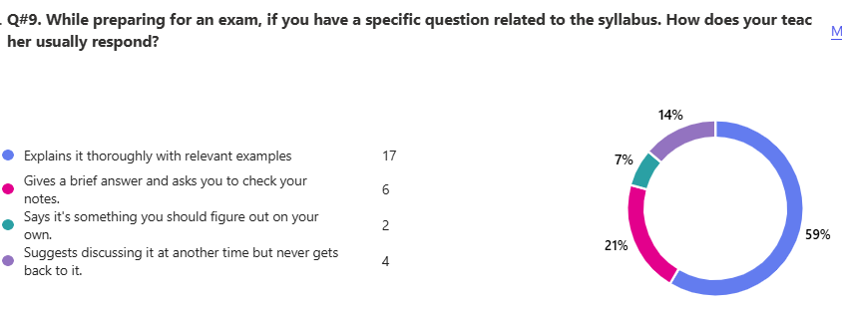

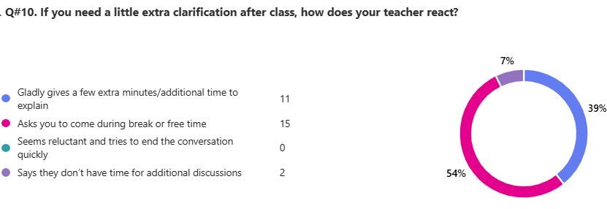

Any feedback that you would like to share with Board of Directors.

ID | Responses
1 | Give us more geography lessons I beg the teacher barely explains and just makes us do work without any proper explanation and then expects to know it all and blames us for not understanding we only have two lessons of geography WE NEED MORE!!
2 | maam asma should explain instead of making us write so many notes
3 | the teachers are nice but some are quite mean ;\
4 | NO
5 | no
6 | idk sGrade 6maaaa
7 | Teachers are nice except one, she two classes every week of 40 mins, we get no break, and it is a little bit annoying. Thank you
8 | all teachers are good but geography teacher doesn't explain well she writes and goes
9 | the maths teacher should not be strict
10 | one thing about computer, that the teacher explains the topic but the main concept isnt clear like the examples r also out of the concept like examples of herself that doesnt makes the concept clear, this doesnt means a personal issue she is very nice but she can improve her explaination
11 | The science teacher Ma'am Sania sometimes Grade 6nores me, and doesn't answer my questions. She also makes me feel excluded.
12 | all teachers are very nice and kind always ready to help
13 | All teachers are amazing and teach very well and question 8 was a bit unfair
14 | I REALLY LIKE MY TEACHERS BUT SOME TEACHERS MAKE US COPY FROM THE BOARD AND IT DOES NO HELP CLEAR MY CONCEPTS OF THE TOPIC
15 | the maths teacher nOUSHEEN gives irrelevant and and doesn't explain properly please hire another
16 | maybe make geo easier..
17 | Our geography teacher does not explain anything just notebook work
18 | all teachers are nice
19 | All the teachers are nice and the maths teacher is very nice and gives a brief explanation of everything and all the teacher encourage us nicely
20 | the maths teacher never explains properly please get us a new teacher ( math )
21 | all teachers are really kind and answers all my questoins nicley

